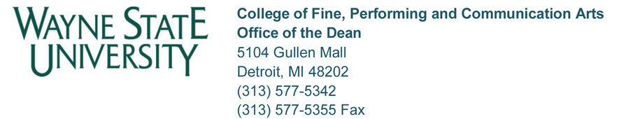

PROMOTION APPLICATION AND REVIEW

Recommended Timelines

August Candidate meets with Chair/Director and Dean’s Office to review promotion process.

Candidate should provide Chair/Director with Personal Statement and WSU Professional Record within a month of meeting so evaluator letters can be sent out.

January Candidate submits one binder and one thumb drive to the Chair/Director. The binder and thumb drive should include items in tabs 1, 5, 6, 7, 8, 13, 14, 15. The Chair/Director adds their recommendation memo to the binder under tab 4, as well as the evaluator information under tabs 9, 10, 11, and 12, then forwards both the thumb drive and the binder to Robin Collins in the Dean’s Office. The College adds to tabs 2 and 3.

January College Promotion Committee meets
to evaluate candidate(s) and make
recommendations.

February Dean’s Office forwards application to Provost’s Office.

March/April University approves or denies. Dean notifies Candidate, Chair/Director.

Dean’s Office prepares EPAF and forwards to HR.

Recommended Material in Request for Promotional Package

1. Cover sheet;
2. Dean’s written recommendation;
3. College promotion and tenure committee’s written recommendation;
4. Department chair’s written recommendation;
5. Unit promotion and tenure committee’s written recommendation-NA;
6. WSU Professional Record; signed and dated;
7. Personal Statement – job performance; professional achievement/scholarship/creative work; service; conclusion.
8. Teaching portfolio, if applicable;
9. Summary of additional evaluators. One letter of evaluation from outside the University is encouraged;
10. Additional evaluators’ letters;
11. Professional summaries of additional evaluators;
12. Sample letter sent to additional evaluators;
13. Miscellaneous information, if applicable;
14. College factors and unit factors;
15. List of publications forwarded, if applicable.

