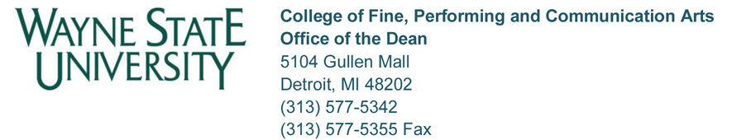

EMPLOYMENT SECURITY STATUS APPLICATION AND REVIEW

Recommended Timelines

8 months prior to fifth anniversary • Candidate meets with Chair/Director and January 2017 Dean’s Office to review ESS process.

Candidate should provide Chair/Director with Personal Statement and WSU Professional Record within a month of meeting so evaluator letters can be sent out.

5 months prior to fifth anniversary • Candidate submits two binders to the
April 3, 2017 Chair/Director. The binders should include items in Tabs 1, 2, 4-7. The Chair/Director adds their recommendation memo to the binders under tab 3, as well as the evaluator letters under tab 6, then forwards the binders to Robin Collins in the Dean’s Office. The binders must include all items, 1-7.

4 months prior to fifth anniversary • College ESS/Promotion Committee meets
May 3, 2017 to evaluate candidate(s) and make
recommendations.

3 months prior fifth anniversary
June 3, 2017 • Dean approves or denies. Dean notifies Candidate, Chair/Director.

Dean’s Office prepares EPAF and forwards to HR.

Recommended Material in Request for ESS Package

1. Cover sheet;
2. Employee’s Personal Request Statement (justification);
3. Recommendation from Chair/Director;
4. Professional Record, signed and dated;
5. Evaluations from previous 4 years;
6. Evidence of excellence in job performance; professional/scholarly and creative achievement; service; conclusion. May include examples of work or letters of evaluation from outside department. Letters of evaluation from outside the University are not encouraged;
7. Copy of ESS/Promotion Factors.

